How to run Relgo Solution Portal in Azure Cloud?
Prerequisites :
- Valid Azure Cloud Subscription
- Resource Group to create Web Apps using App Services.

Step 1 : Login in to Azure portal
Step 2: Create a Container instance for OCL as below
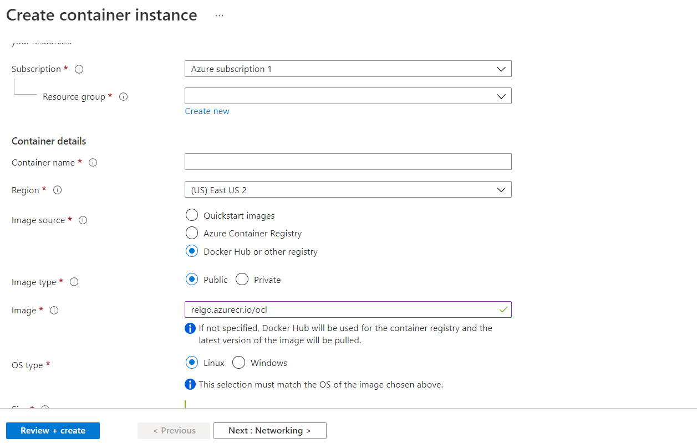 | Latest Image URL : relgonetworks/ocl:latest
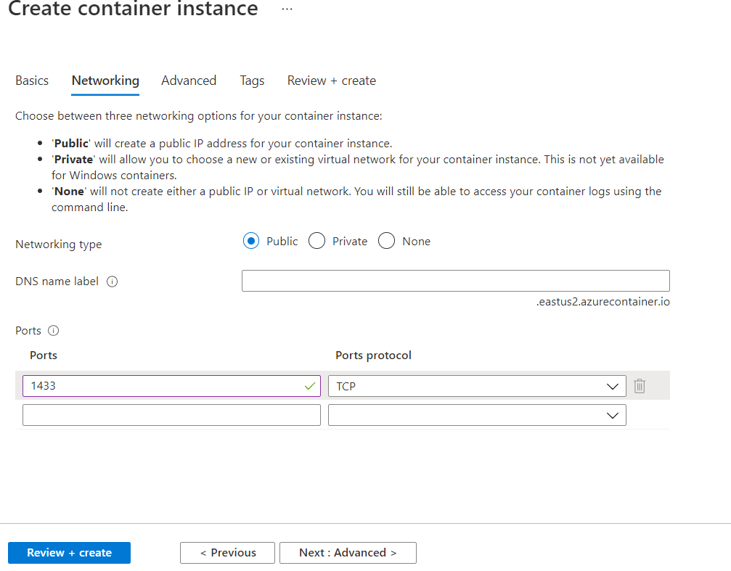 | In Step 2 , Replace port 80 with 1433 as shown in the image.
SQL Server on Linux requires few parameters for its installation. In the advanced tab, we need to assign those environment variables with their values.
- ACCEPT_EULA=Y: To accept the end-user license agreement
- MSSQL_SA_PASSWORD=relgo123* ( SQL Server SA password)

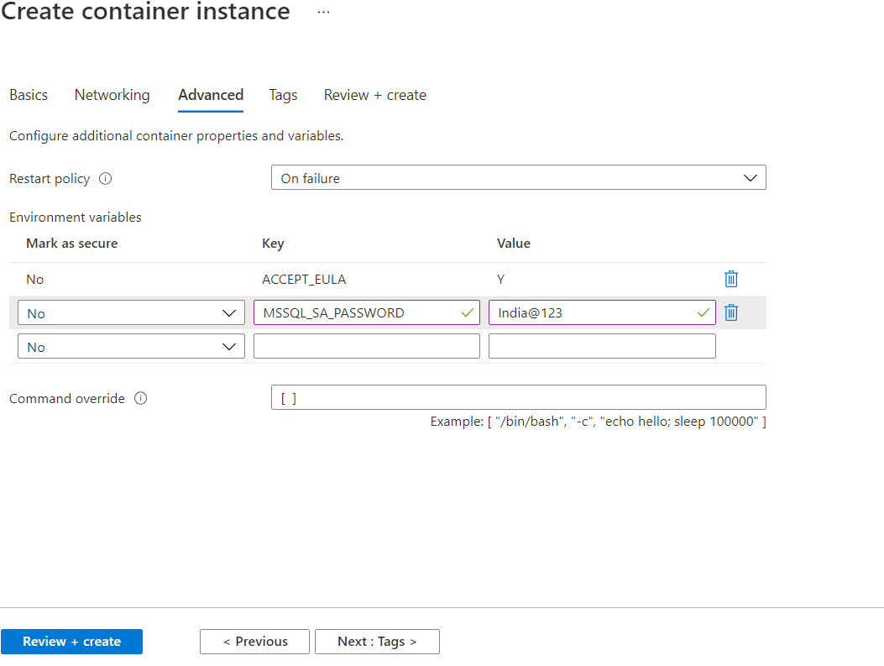
Click on “Review + Create” to create container instance for OCL
After successful creation of OCL container, attach OCL DB using SQL Management Studio.  - Check public IP of OCL container  - Login in to SQL management using xx.xx.xx.xx,1433  - Attach OCL DB as below | xx: Public IP of OCL container.  Make a not of public IP which needs to be used in (RellationsNetLive) application configuration settings
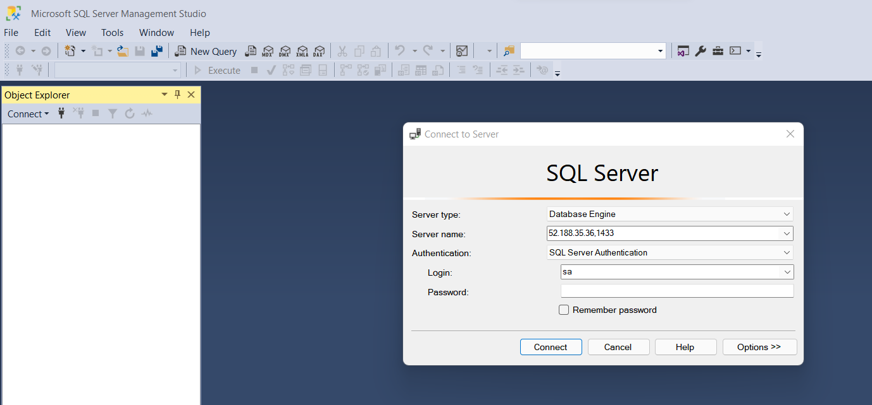
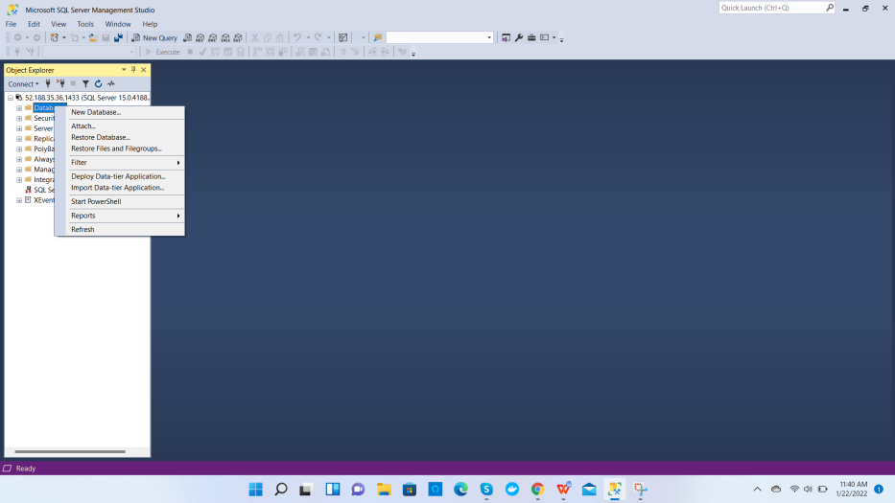 | Select “Attach” option from the list.
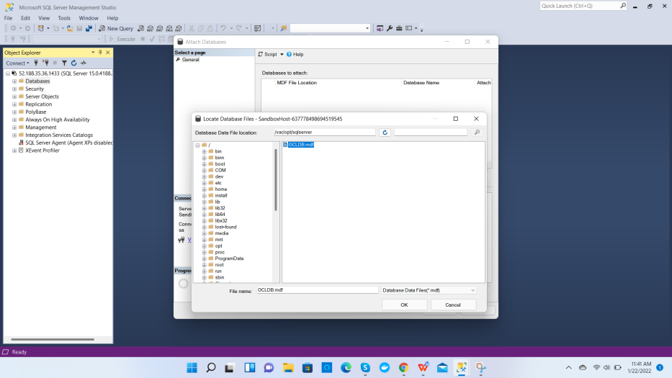
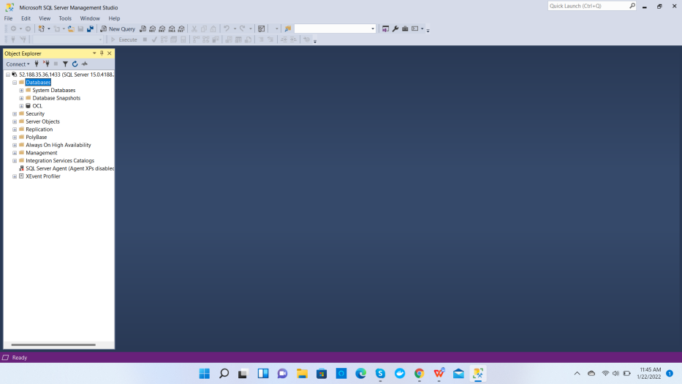
Step 3 : Create a Web App for ‘RelationsNetLive ‘ as below : | 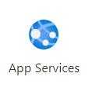
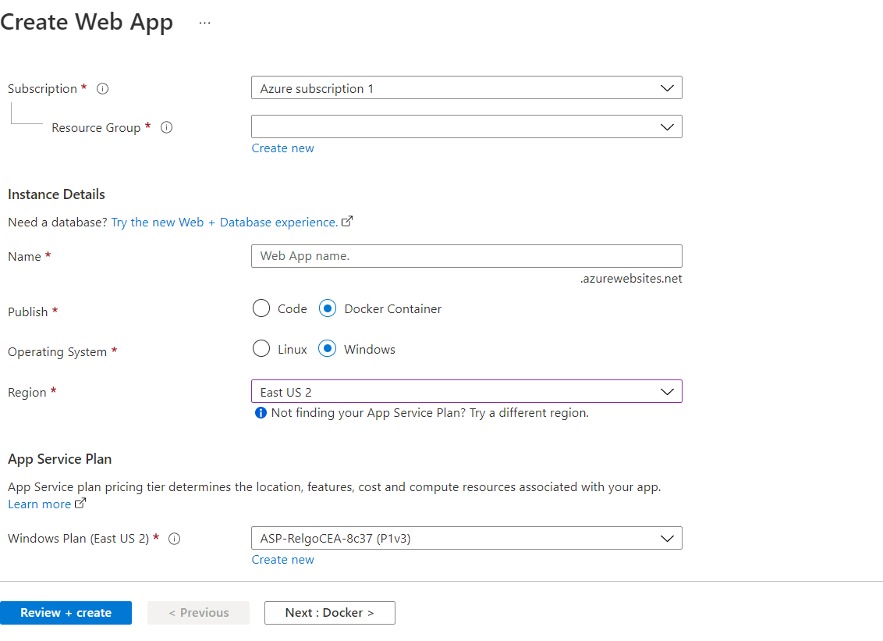
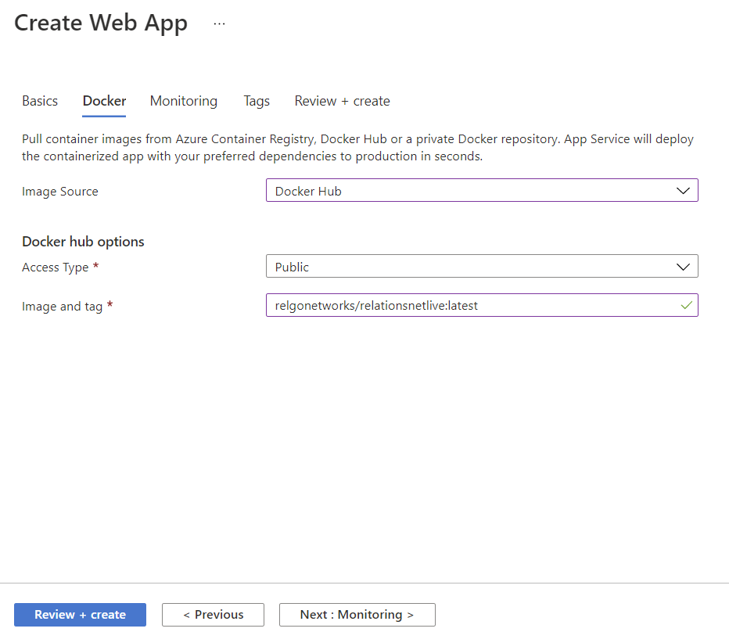 | Image URL :  relgonetworks/relationsnetlive:latest
Click on “Review + Create” to create web app in azure. After few minutes your applications will be in live.

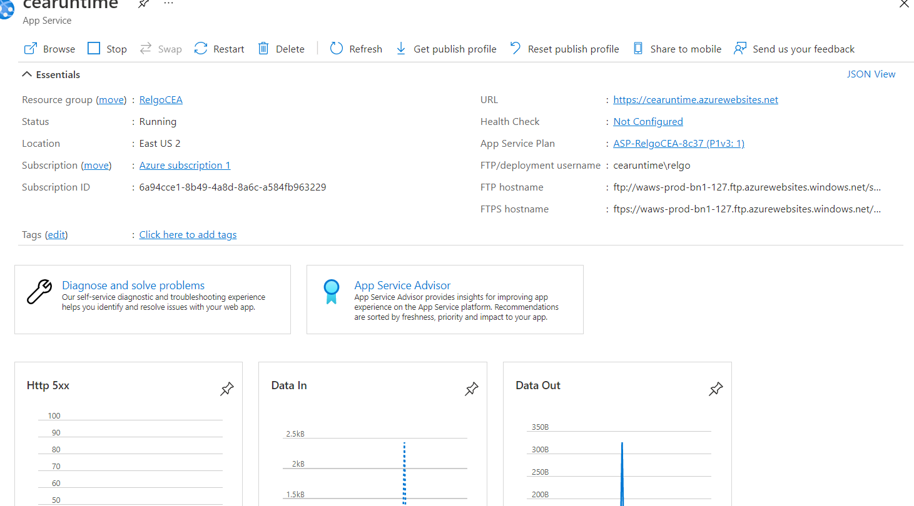
Now update application configuration settings as below.  Click on configuration under settings . Click on Advanced Edit and copy paste below application settings in JSON format.  [  {  "name": "AppDesignAdminAccount",  "value": "adminapps@relgo.com",  "slotSetting": false  },  {  "name": "CachedMode",  "value": "false",  "slotSetting": false  },  {  "name": "ConnectionString",  "value": "Data Source=xx.xxx.xx.xx,1433;Initial Catalog=OCL;User Id=sa;pwd=relgo123*",  "slotSetting": false  },  {  "name": "DefaultNameSpace",  "value": "http://www.inkaar.com/Relations",  "slotSetting": false  },  {  "name": "RelgoServiceProvider",  "value": "service@relgo.com",  "slotSetting": false  },  {  "name": "RelgoUserFormsUrl",  "value": "http://xxxxx.azurewebsites.net/RelationsNet.asmx",  "slotSetting": false  },  {  "name": "Serviceids",  "value": "c598882f-7b30-4ff7-9615-4c52e9257492,400f9779-4d8b-4869-b49f-f1196560b946",  "slotSetting": false  }  ]  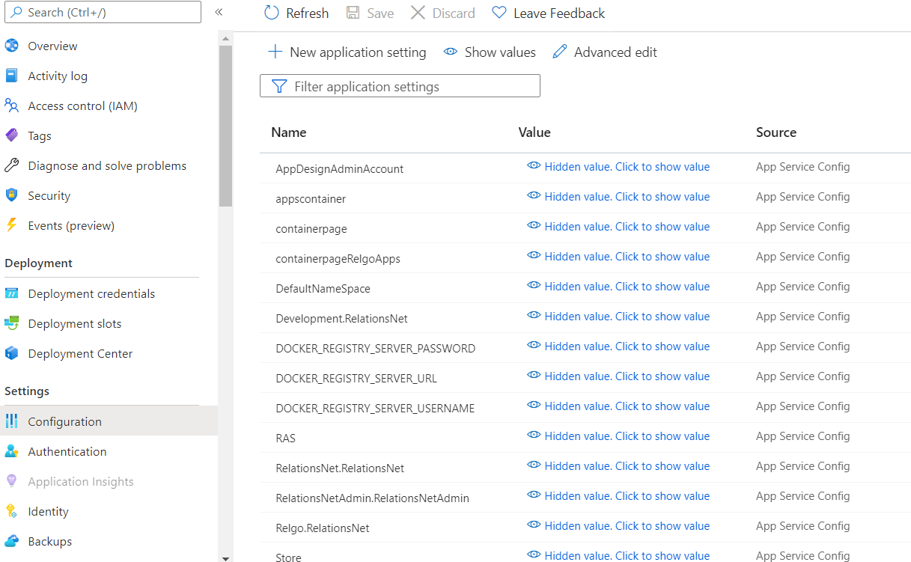 | Xxxx.azurewebsites.net  Replace xxxx with web app name after you create the instance.  Data Source=xx.xxx.xx.xx,1433;Initial Catalog=OCL;User Id=sa;pwd=relgo123*  Replace xx.xxx.xx.xx with public ip of your DB (OCL) instance.
Step 4 : Create a Web App for ‘RelgoAppsLive’ as below :
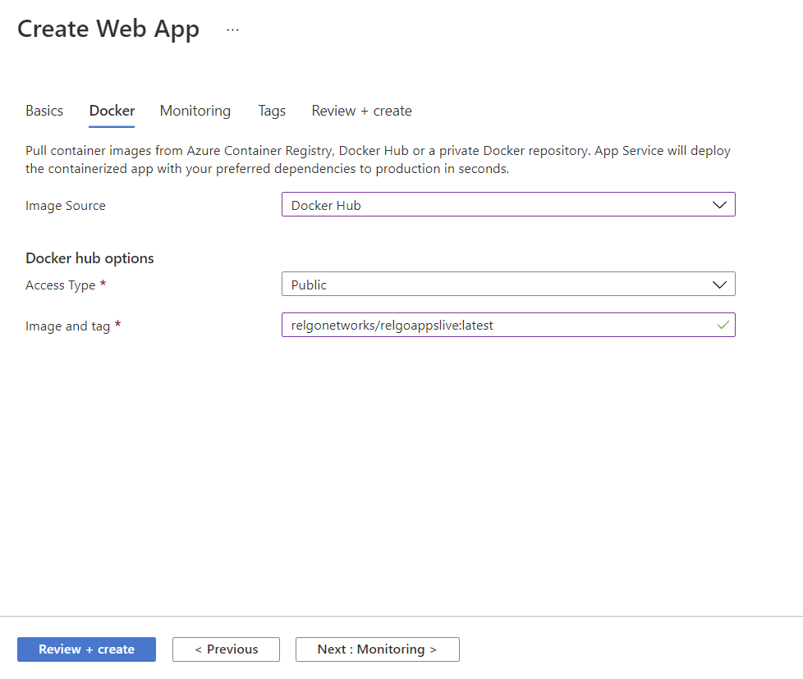 | Image URL :  relgonetworks/relgoappsive:latest
Click on “Review + Create” to create web app in azure. After few minutes your applications will be in live.

Now update application configuration settings as below.  Click on configuration under settings . Click on Advanced Edit and copy paste below application settings in JSON format.  [  {  "name": "AppDesignAdminAccount",  "value": "appstore@relgo.com",  "slotSetting": false  },  {  "name": "authorize",  "value": "service@relgo.com,relgosourcesafe@relgo.com,appstore@relgo.com",  "slotSetting": false  },  {  "name": "Checkindetailsform",  "value": "relgosourcesafe@relgo.com_checkinapplication@relgo.com",  "slotSetting": false  },  {  "name": "container",  "value": "http://relgoappslive.azurewebsites.net/container.aspx?",  "slotSetting": false  },  {  "name": "containerpagedev",  "value": "http://relgoappsdev.azurewebsites.net/Container.aspx",  "slotSetting": false  },  {  "name": "containerpageops",  "value": "http://relgoappslive.azurewebsites.net/Container.aspx",  "slotSetting": false  },  {  "name": "dashboard",  "value": "http://relgoappslive.azurewebsites.net/dashboard.aspx",  "slotSetting": false  },  {  "name": "DefaultNameSpace",  "value": "http://www.inkaar.com/Relations",  "slotSetting": false  },  {  "name": "Development.RelationsNet",  "value": "http://relationsnetdev.azurewebsites.net/RelationsNet.asmx",  "slotSetting": false  },  {  "name": "Relgo.RelationsNet",  "value": "http://relgo.com:1115/RelationsNet.asmx",  "slotSetting": false  },  {  "name": "enableaccess",  "value": "True",  "slotSetting": false  },  {  "name": "MenuFromName",  "value": "Module Feature Mapping,Feature Task Group Mapping,Task Group Task Mapping",  "slotSetting": false  },  {  "name": "Nonsecuresite",  "value": "http:",  "slotSetting": false  },  {  "name": "prodctiondevcloud",  "value": "http://relationsnetdev.azurewebsites.net/relationsnet.asmx",  "slotSetting": false  },  {  "name": "Production",  "value": "http://relationsnetlive.azurewebsites.net/RelationsNet.asmx",  "slotSetting": false  },  {  "name": "PublishingAccount",  "value": "appstore@relgo.com",  "slotSetting": false  },  {  "name": "RelationsNet.RelationsNet",  "value": "http://relationsnetlive.azurewebsites.net/RelationsNet.asmx",  "slotSetting": false  },  {  "name": "RelgoServiceId",  "value": "ec65ea94-2bad-48d5-bd86-5f2211c88bdb",  "slotSetting": false  },  {  "name": "RelgoUserFormsUrl",  "value": "http://relationsnetlive.azurewebsites.net/RelationsNet.asmx",  "slotSetting": false  },  {  "name": "securesite",  "value": "https:",  "slotSetting": false  },  {  "name": "storeid",  "value": "relgostore@31a6129b-4b28-449e-b51d-025e0893f47c.4e4911e2-d6c8-4cc5-8fce-007356b3ba53.relgo.com",  "slotSetting": false  },  {  "name": "VersionAdmin",  "value": "relgosourcesafe@relgo.com",  "slotSetting": false  }  ] | Xxxx.azurewebsites.net  Replace xxxx with web app name after you create the instance.
Step 5 : Create a Web App for ‘ROC’ as below :
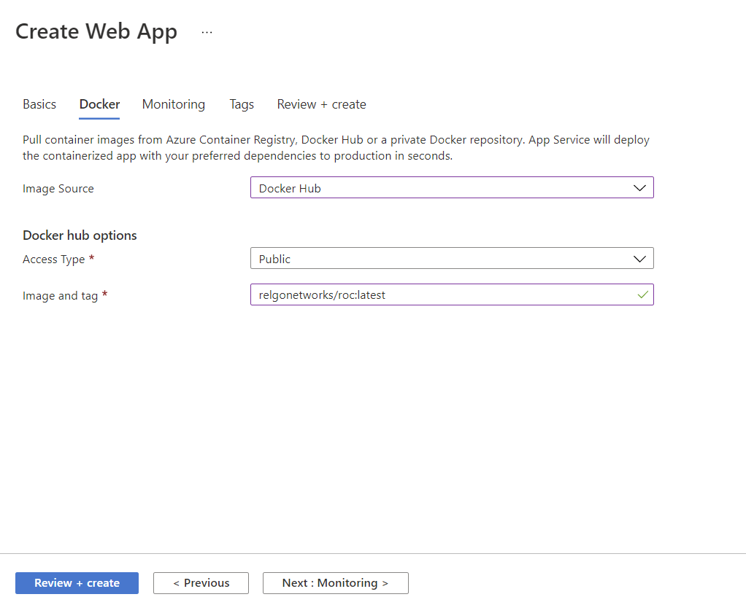 | Image URL :  relgonetworks/roc:latest
Click on “Review + Create” to create web app in azure. After few minutes your applications will be in live.

Now update application configuration settings as below.  Click on configuration under settings . Click on Advanced Edit and copy paste below application settings in JSON format.  [  {  "name": "AppDesignAdminAccount",  "value": "appstore@relgo.com",  "slotSetting": false  },  {  "name": "appscontainer",  "value": "http://xxxxxx.azurewebsites.net/Container.aspx",  "slotSetting": false  },  {  "name": "containerpage",  "value": "http://xxxx.azurewebsites.net/container.aspx",  "slotSetting": false  },  {  "name": "containerpageRelgoApps",  "value": "/xxxx.azurewebsites.net/Container.aspx",  "slotSetting": false  },  {  "name": "DefaultNameSpace",  "value": "http://www.inkaar.com/Relations",  "slotSetting": false  },  {  "name": "Development.RelationsNet",  "value": "http://xxxx.azurewebsites.net/RelationsNet.asmx",  "slotSetting": false  },  {  "name": "RAS",  "value": "http://xxxx.azurewebsites.net",  "slotSetting": false  },  {  "name": "RelationsNet.RelationsNet",  "value": "http://xxxx.azurewebsites.net/RelationsNet.asmx",  "slotSetting": false  },  {  "name": "RelationsNetAdmin.RelationsNetAdmin",  "value": "http://xxx.azurewebsites.net/RelationsNetAdmin.asmx",  "slotSetting": false  },  {  "name": "Relgo.RelationsNet",  "value": "http://relgo.com:1115/RelationsNet.asmx",  "slotSetting": false  },  {  "name": "Store",  "value": "appstore@relgo.com",  "slotSetting": false  },  {  "name": "VersionAdmin",  "value": "relgosourcesafe@relgo.com",  "slotSetting": false  },  ] | Xxxx.azurewebsites.net  Replace xxxx with web app name after you create the instance.

