How to run Relgo containerized business applications using Docker desktop on windows 10 Pro or Enterprise?

Step 1. Download and install docker-desktop for windows from https://www.docker.com/products/docker-desktop

During installation, make sure Enable Hyper-V feature selected and click on OK to complete installation process and restart your computer.

Step 2: After successful installation, go to docker properties and click on “Switch to Windows containers”.

Step 3: Setup running environment for containerized application.
NOTE : Make sure you have logged in to docker account before executing following commands.

3.1 Download docker images from docker hub by running following commands in windows power shell.

Docker pull relgonetworks/roc:latest
Docker pull relgonetworks/relgoappslive:latest
Docker pull relgonetworks/relationsnetlive:latest
Docker pull relgonetworks/ocl:1.1

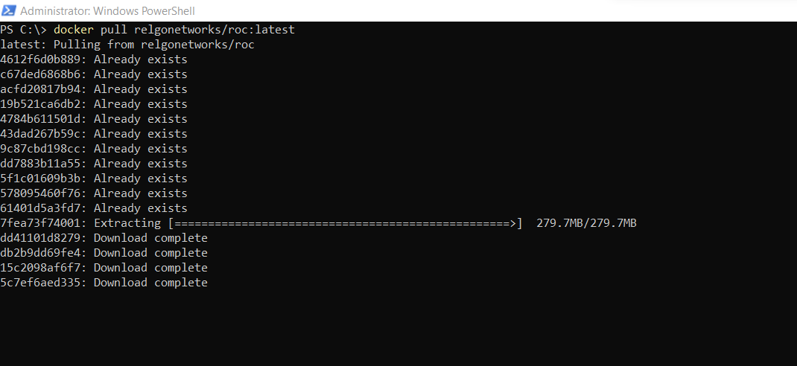

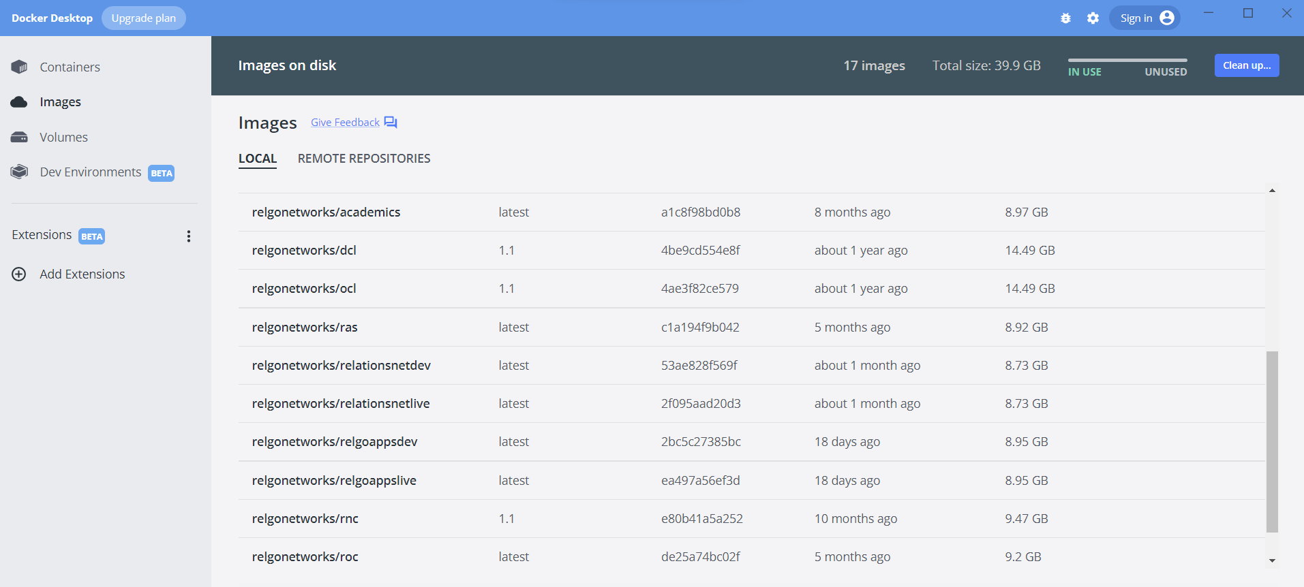

3.2
Create a new folder called “temp” in C drive.

Download OCLDB.mdf zip file from the following url. Extract OCLDB.mdf from downloaded zip file and copy to temp folder in C drive https://relgo.com/Resources/@Bizcenter$5f19b2f2-8245-4f97-98ac-04c8ab231415-OCLDB_1.0.zip

Download OCLDB_log.ldf zip file from the following url. Extract OCLDB_log.ldf from downloaded zip file and copy to temp folder in C drive
https://relgo.com/Resources/@Bizcenter$7ae9ea5f-353d-4bde-b006-6bf2bf94dbda-OCLDB_log_1.0.zip

Open windows power shell and run the following commands one by one.

3.3 docker network create --driver=nat --subnet=172.28.0.0/16 --gateway=172.28.0.1 relgonet

For Linux Environment :
docker network create --subnet 172.28.0.0/16 --ip-range 172.28.0.0/20 relgonet

3.4 docker run -d --name "OCL" --net=relgonet --ip=172.28.0.4 -p 1433:1433 -v C:/temp/:C:/temp/ -e sa_password=relgo123* -e ACCEPT_EULA=Y -e attach_dbs="[{'dbName':'OCL','dbFiles':['C:\\temp\\ocldb.mdf','C:\\temp\\ocldb_log.ldf']}]" relgonetworks/ocl:1.1

For Linux Environment :
docker run -d --name "OCL" --ip=172.28.0.4 -p 1433:1433 -e sa_password=relgo123* -e ACCEPT_EULA=Y relgonetworks/ocl:latest

3.5 docker run -d --name "RelationsNetLive" --net=relgonet --ip=172.28.0.3 -p 9255:80 relgonetworks/relationsnetlive:latest

3.6 docker run -d --name "ROC" --net=relgonet --ip=172.28.0.2 -p 9254:80 relgonetworks/roc:latest

3.7 docker run -d --name "RelgoAppsLive" --net=relgonet --ip=172.28.0.5 -p 9256:80 relgonetworks/relgoappslive:latest

NOTE : Run below commands, if you are looking for Relgo Solution Builder for building applications online and deploy in any cloud. You may require license to use Relgo Solution Builder.

Download DCLDB.mdf zip file from the following url. Extract DCLDB.mdf from downloaded zip file and copy to temp folder in C drivehttps://relgo.com/Resources/@Bizcenter$57448352-8fa2-46e0-b953-271581492cf9-DCLDB_1.0.zip

Download DCLDB_log.ldf zip file from the following url. Extract DCLDB_log.ldf from downloaded zip file and copy to temp folder in C drivehttps://relgo.com/Resources/@Bizcenter$02fa4307-b503-4a78-a9ed-dec26a31965b-DCLDB_log_1.0.zip

Download docker images from docker hub by running following commands in windows power shell.

Docker pull relgonetworks/relgoappsdev:latest
Docker pull relgonetworks/relationsnetdev:latest
Docker pull relgonetworks/ras:latest
Docker pull relgonetworks/dcl:1.1

docker network create --driver=nat --subnet=172.28.0.0/16 --gateway=172.28.0.1 relgonet

3.8 docker run -d --name "RelationsNetDev" --net=relgonet --ip=172.28.0.6 -p 9257:80 relgonetworks/relationsnetdev:latest

3.9 docker run -d --name "RelgoAppsDev" --net=relgonet --ip=172.28.0.7 -p 9258:80 relgonetworks/relgoappsdev:latest

3.10 docker run -d --name "DCL" --net=relgonet --ip=172.28.0.8 -p 2433:1433 -v C:/temp/:C:/temp/ -e sa_password=relgo123* -e ACCEPT_EULA=Y -e attach_dbs="[{'dbName':'DCL','dbFiles':['C:\\temp\\dcldb.mdf','C:\\temp\\dcldb_log.ldf']}]" relgonetworks/dcl:1.1

3.11 docker run -d --name "RAS" --net=relgonet --ip=172.28.0.9 -p 9259:80 relgonetworks/ras:latest

3.12 docker run -d --name "RNC" --net=relgonet --ip=172.28.0.10 -p 9260:80 relgonetworks/rnc:1.1

After successful execution of above commands now you can access roc site from your browser by typing http://172.28.0.2

Now, you can create token by validating your email address and select token to login ROC site.

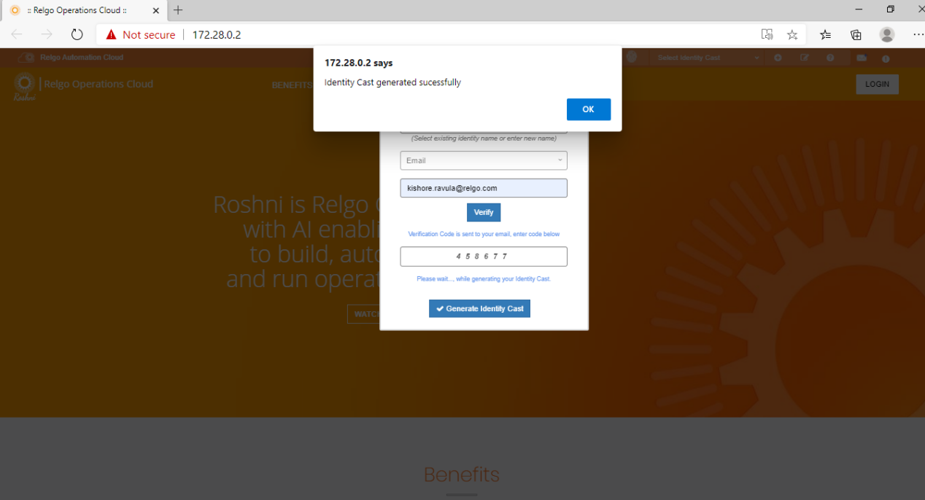

NOTE : IF YOU WANT TO ENABLE “RELATIONS NET URL” PUBLIC ACCESSIBLE, PLEASE FOLLOW FOLLOWING STEPS.

How to make your IP public accessible?
Here I am going to use port forwarding technique to make you IP public accessible.

STEP 1 : Login to http://portmap.io or register yourself if you do not have an account.

STEP 2 : After login, go to Configurations and create new configuration as below.
Name : As per your choice like “RDP”
Type : OpenVPN (We are going to OpenVPN configuration settings to enable to pubic access to RelationsNet URL.
Port : TCP

Click on Generate button, will generate OpenVPN configuration file and down load the same to your system.

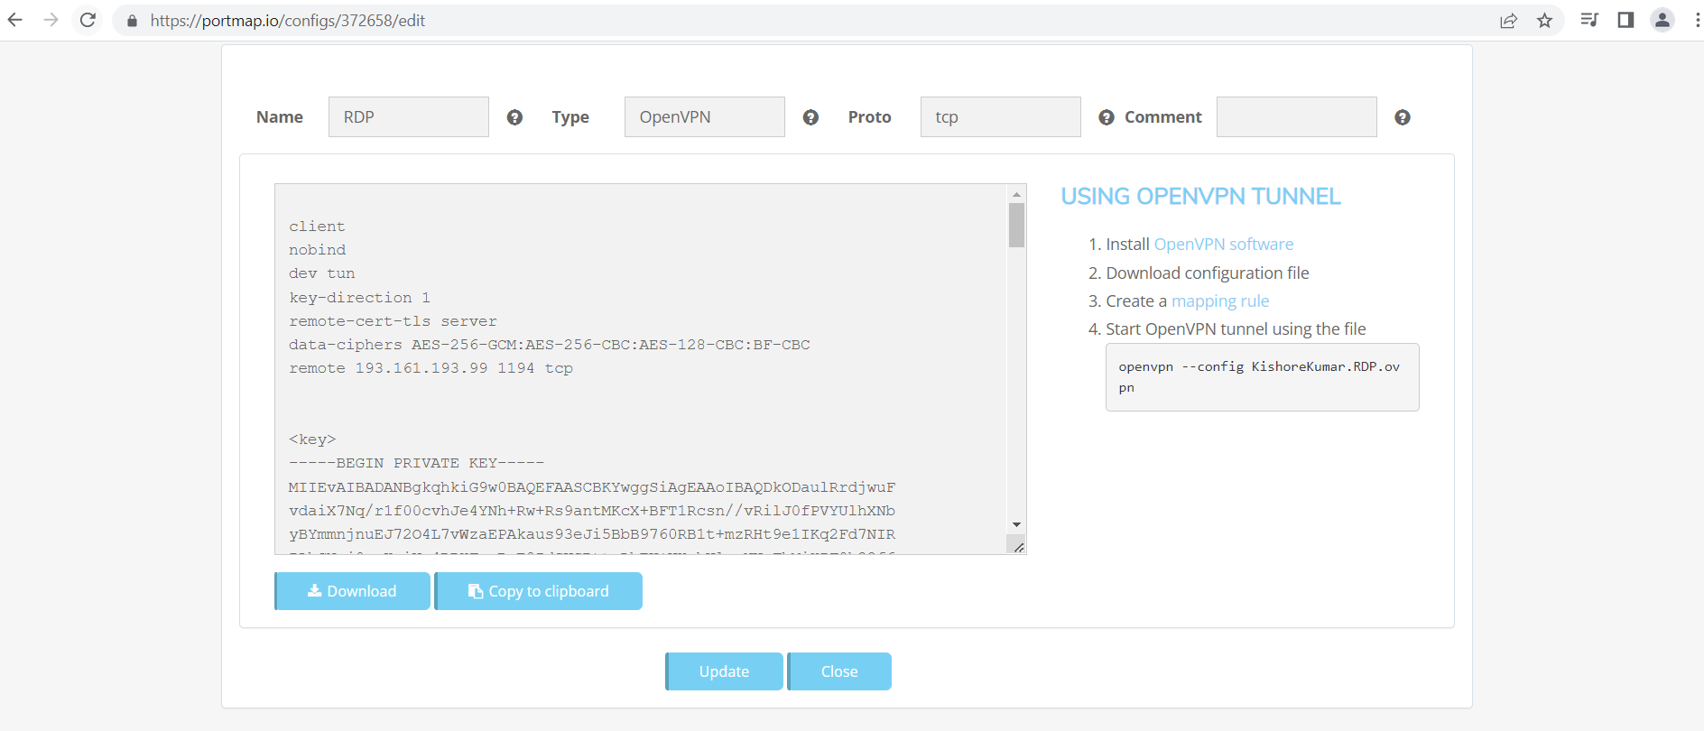

STEP 2: Now Go to MAPPING RULE and Click on “Create New Rule”.
No need to change default data and Just give Port on your PC as “9255” or the port number you have given during RelationsNet docker container creation.

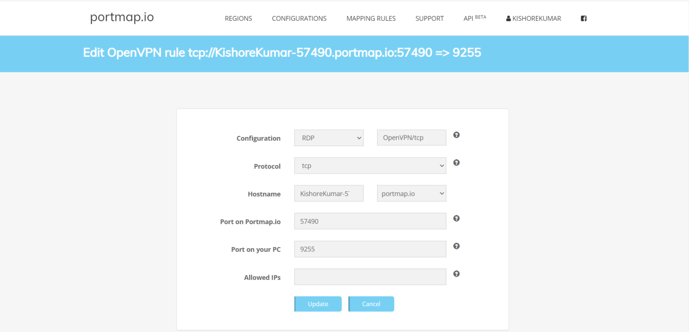

STEP 3 : Now you just run open Open VPN software and select the open VPN configuration file. You need to install, if you have not already installed Open VPN software.
https://openvpn.net/community-downloads/

Now you should able to access your relations net URL from any where through system browser.

REFERENCE : https://www.youtube.com/watch?v=YE2L0uT153w

